**BACKLOG**

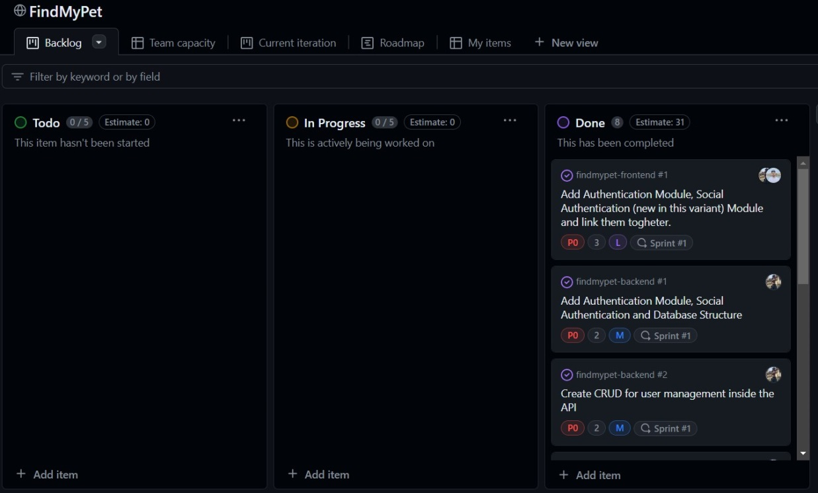

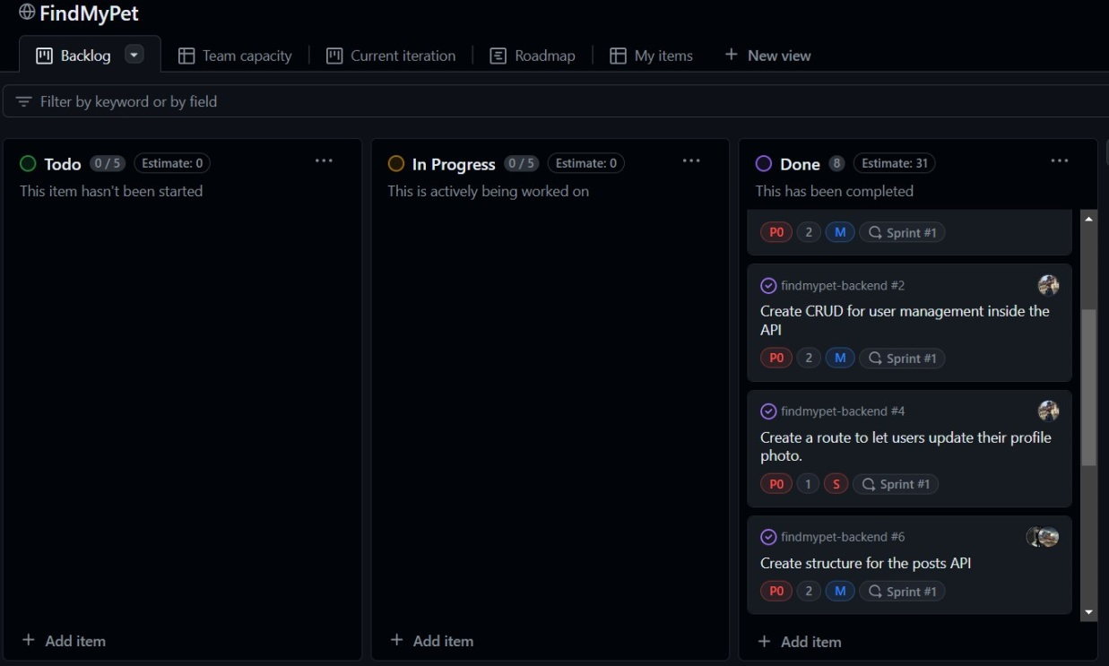

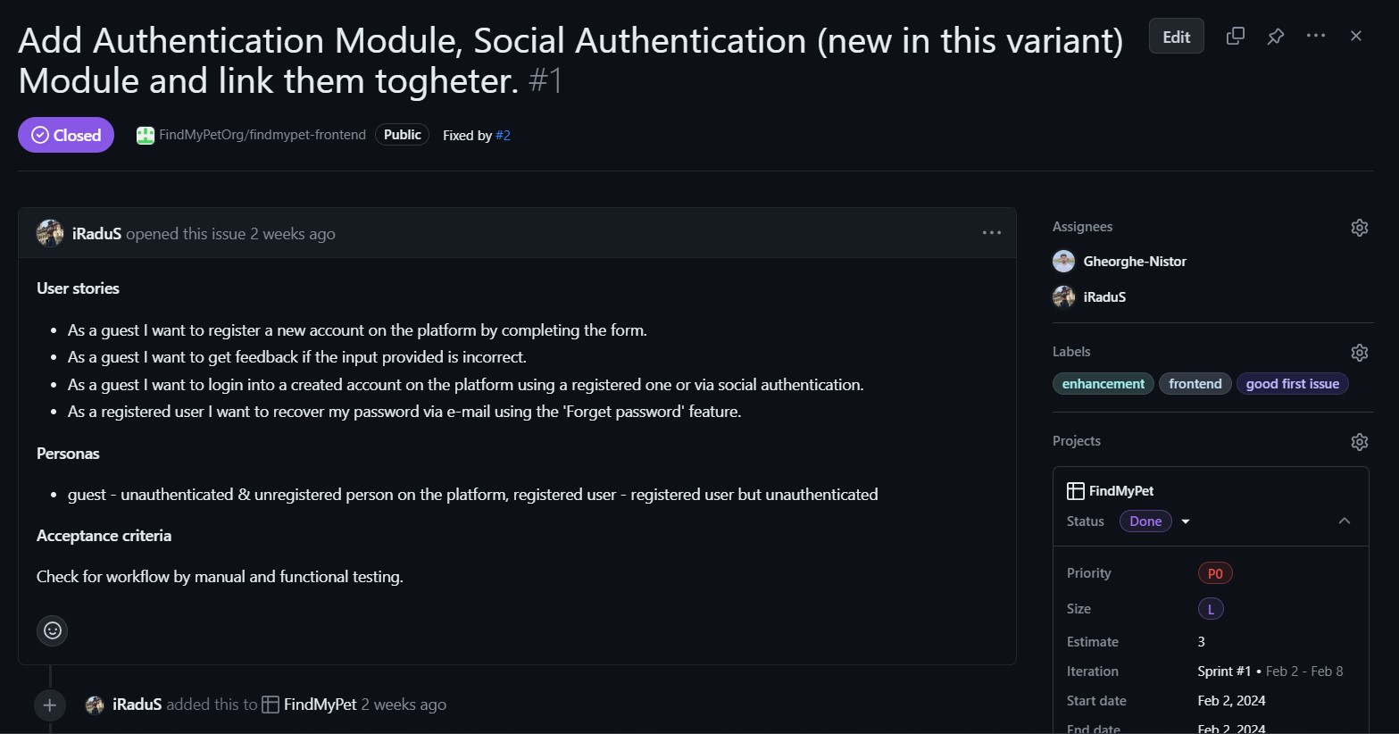

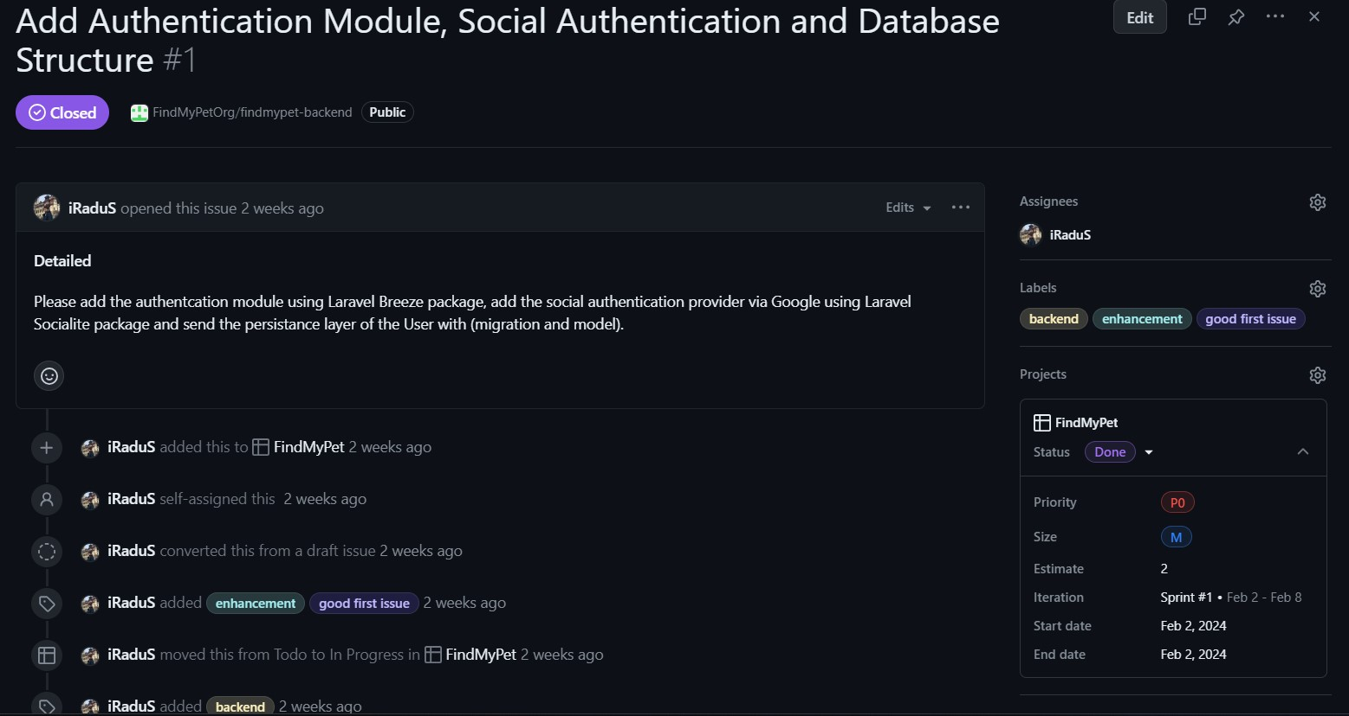

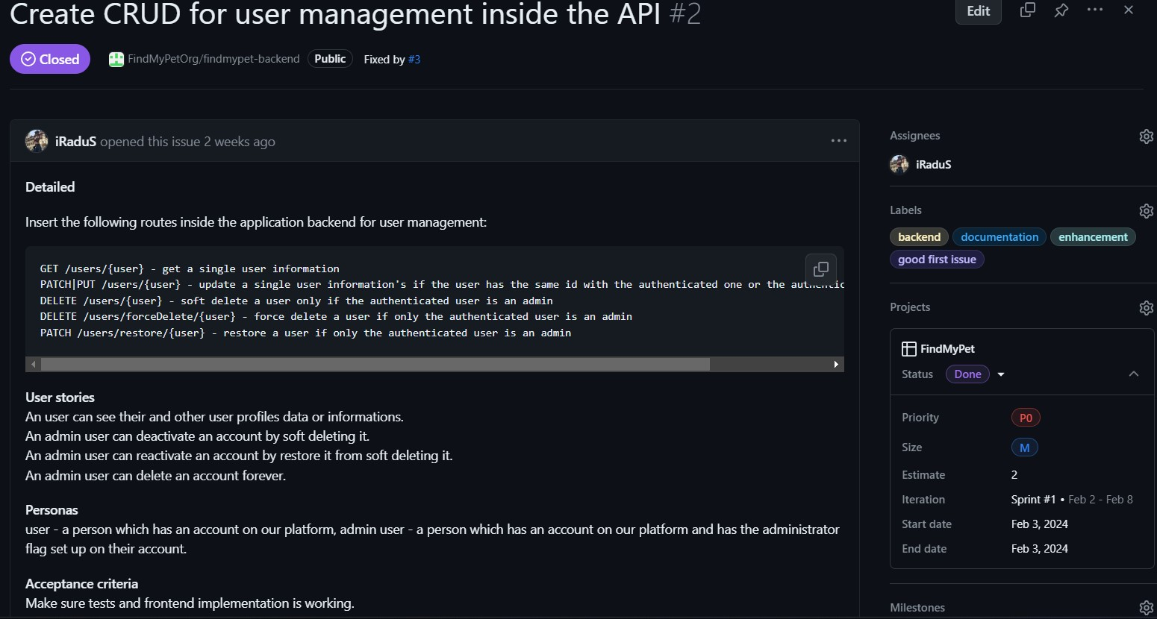

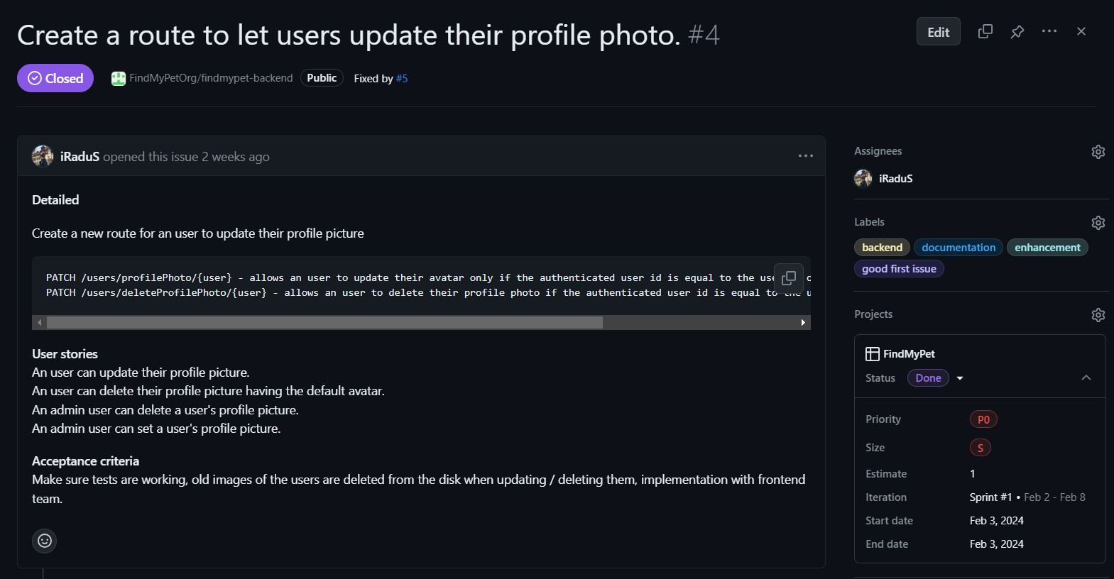

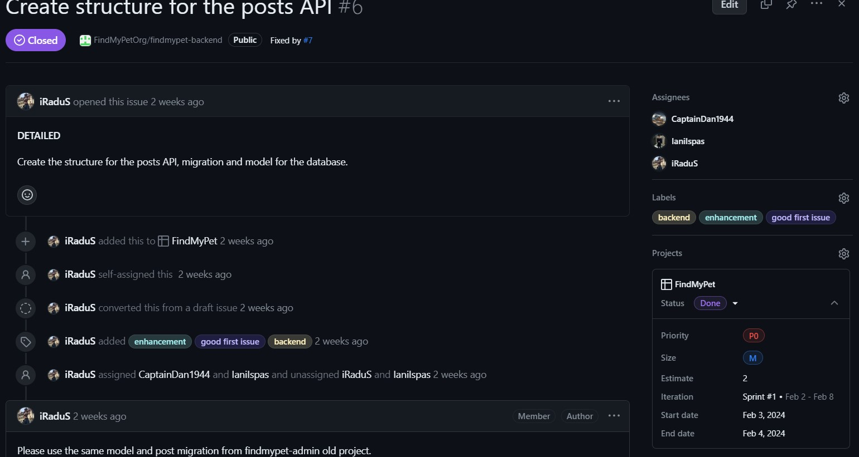

<https://github.com/FindMyPetOrg/findmypet-frontend/issues/1>

<https://github.com/FindMyPetOrg/findmypet-backend/issues/1>

<https://github.com/FindMyPetOrg/findmypet-backend/issues/2>

<https://github.com/FindMyPetOrg/findmypet-backend/issues/4>

<https://github.com/FindMyPetOrg/findmypet-backend/issues/6>